# Create High Availability Architecture with AWS CLI

Description:

⭐Webserver configured on EC2 Instance

⭐ Document Root(/var/www/html) made persistent by mounting on EBS Block Device.

⭐Static objects used in code such as pictures stored in S3

⭐Setting up a Content Delivery Network using CloudFront and using the origin domain as an S3 bucket.

⭐Finally, place the Cloud Front URL on the web app code for security and low latency.

Step1: Configure AWS CLI and Launch EC2 instance

As we are creating Infrastructure using CLI. CLI should be configured in your system if not you can refer to the above article. In this article, I already explained how to Configure CLI, create key-pair, launch ec2 instance and security-group.

Step2: Configure Webserver on EC2 Instance

here I have one instance launched using the process as I mentioned in the above article.

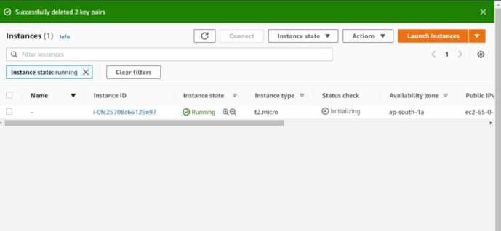

By default, the Web server Works On port 80 so we need to add a rule in the security group to allow traffic from port 80 and the client can able to access WebPages and allow port 22 for SSH.

aws ec2 authorize-security-group-ingress --group-name CLI --protocol tcp --port 80 --cidr 0.0.0.0/0  
aws ec2 authorize-security-group-ingress --group-name CLI --protocol tcp --port 22 --cidr 0.0.0.0/0

**Install webserver on Instance[Apache webserver]**

**Start Webservice**

systemctl start httpd#TO make permanent#TO make permanent  
systemctl enable httpd

Step3: Create EBS Volume and mount to /var/www/html folder

**Create EBS Volume**

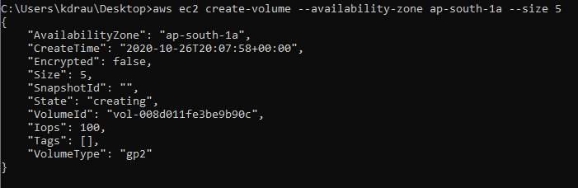

**Attach Volume to an instance**

**Run below command in the instance**

fdisk -l

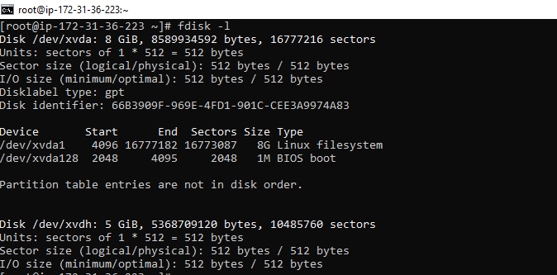

**Create Partition**

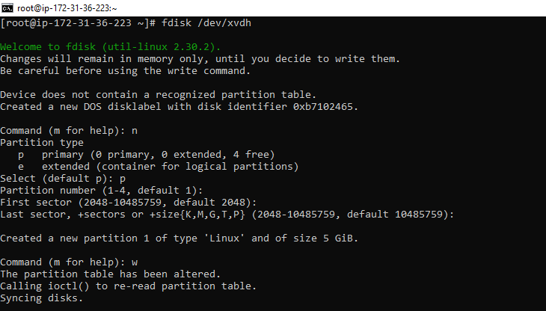

**format partition**

mkfs.ext4 /dev/xvdh1

**Mount to /var/www/html**

mount /dev/xvdh1 /var/www/html

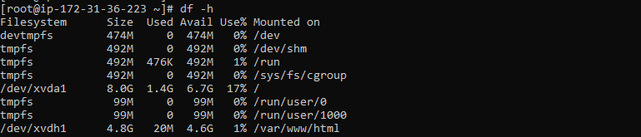

Step4: Create an S3 bucket and Upload object using CLI

There is a more powerful command available for s3 ==>**s3api** which has more features and gives more flexibility.

Regions outside of “us-east-1” require the appropriate  
“LocationConstraint” to be specified in order to create the bucket in  
the desired region.

aws s3api create-bucket — bucket bucker123123123 — region "ap-south-1" --acl public-read — create-bucket-configuration **LocationConstraint=ap-south-1**

**Upload Object to s3**

aws s3 cp File_name_in_local_system s3://bucker_name  
or   
aws s3api put-object --bucket bucker123123123 --key aws2.jpg --body aws2.jpeg ***--content-type image/jpeg***

make sure you have given the correct***content-type.***here if you don’t give content-type image/jpg. URL instead of view downloads image this won’t work directory using URL we have to some more thing on the webpage to show an image.

**Change Object Policy**

aws s3api put-object-acl --bucket bucker123123123 --key aws2.jpg   
--acl public-read

Step5: create CloudFront distribution

aws cloudfront create-distribution --origin-domain-name bucker123123123.s3.amazonaws.com

**Step6: Create web page /var/www/html and use cloudFront URL to use image in s3**

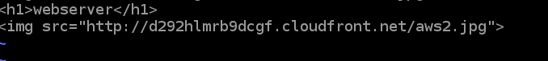

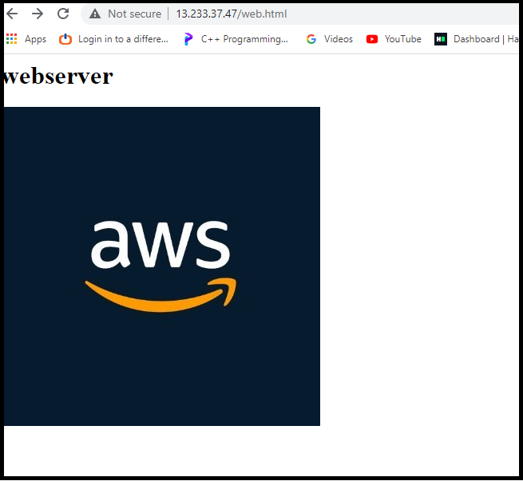

Successfully completed

**THANK YOU**